Docker WORKBOOK – 1

# Running docker containers

* Run hello-world docker container and observe the container status
* Check the docker images and also write down the size of hello-world image
* 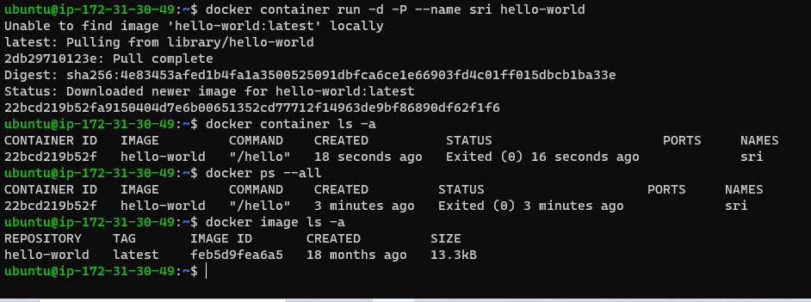
* Run the nginx container with name as nginx1 and expose it on 8080 port on docker host
* 
* 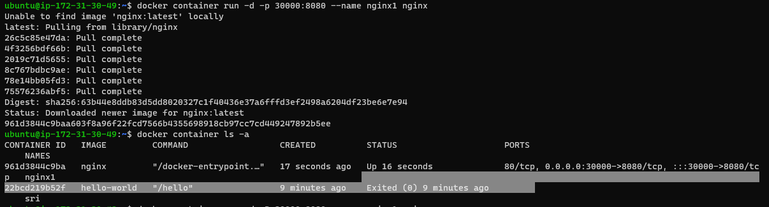
* Explain docker container lifecycle
* 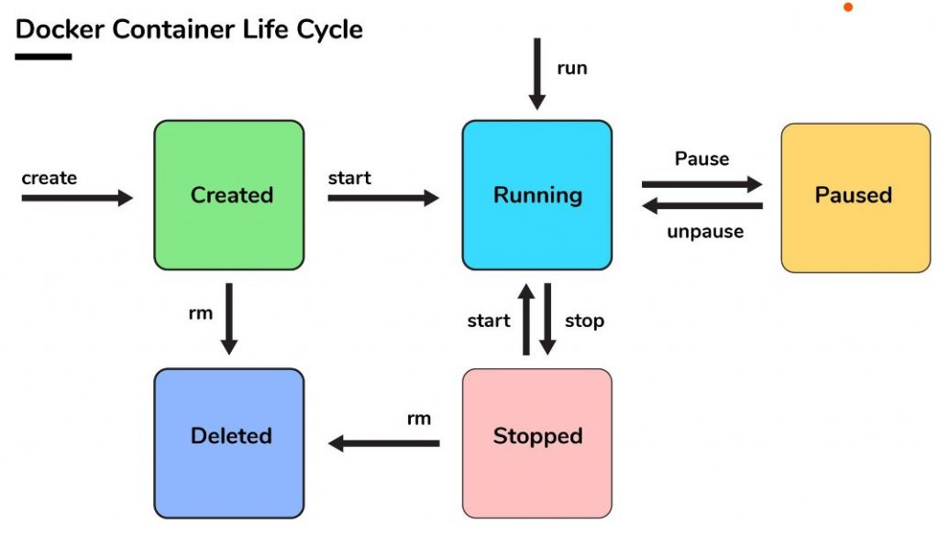
* Explain what happens when you run the docker container

CMD command wil execute

* Show all the states of docker container on nginx based container
* Explain docker architecture